Database Express 12C 配置

###指定端口登录

1、配置CDB

1. [oracle@12cnod01 ~]$ sqlplus / as sysdba
2. SQL> exec dbms_xdb_config.sethttpport(5500)
3. SQL> select dbms_xdb_config.gethttpport() from dual;
4. <http://10.10.8.50:5500/em>
5. 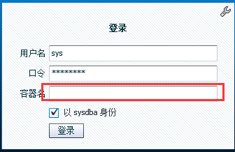
6. 红色留空不填写，不然登录不进去

二、PDB配置

1. 与CDB要分别在不同的端口上，可以对不同的PDB指定不同的端口
2. SQL> show pdbs;

CON_ID CON_NAME OPEN MODE RESTRICTED

1. ---------- ------------------------------ ---------- ----------
2. 2 PDB$SEED READ ONLY NO
3. 3 ORADBPDB1 MOUNTED
4. 4 ORADBPDB2 MOUNTED
5. 5 SALESACT MOUNTED

6 SALESACT01 MOUNTED

1. 7 ORADBPDB3 MOUNTED
2. SQL> alter pluggable database ORADBPDB1 open;
3. SQL> conn sys/cz123456@ORADBPDB1 as sysdba
4. SQL> show pdbs;
5. CON_ID CON_NAME OPEN MODE RESTRICTED
6. ---------- ------------------------------ ---------- ----------
7. 3 ORADBPDB1 READ WRITE NO
8. SQL> exec dbms_xdb_config.sethttpport(5501)

SQL> select dbms_xdb_config.gethttpport() from dual;

1. <http://10.10.8.50:5501/em/login>
2. 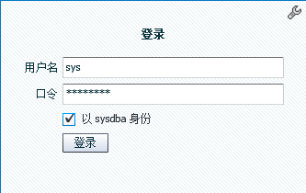
3. 取消端口

exec dbms_xdb_config.sethttpport(0)

####全局端口设置（推荐使用）

区别于独立的端口访问，全局端口可以在登录界面直接数据PDB名就可以登录

1. 关闭监控端口

SQL> exec dbms_xdb_config.sethttpport(0)

PL/SQL procedure successfully completed.

SQL> select dbms_xdb_config.gethttpport() from dual;

DBMS_XDB_CONFIG.GETHTTPPORT()

-----------------------------

0

1. 开启全局端口（CDB操作）

SQL> exec dbms_xdb_config.sethttpport(5600)

PL/SQL procedure successfully completed.

SQL> exec dbms_xdb_config.setglobalportenabled(true)

PL/SQL procedure successfully completed.

1. 登录PDB开始全局设置

SQL> conn sys/cz123456@ORADBPDB1 as sysdba

SQL>exec dbms_xdb_config.sethttpport(0)

SQL> exec dbms_xdb_config.setglobalportenabled(true)

填写就是登录PDB，不填写就是CDB

